

**A Minor Project Report on**

**TEACHING BOARD WIPER**

**Submitted by**

**ANCHANA B (927621BEE006)**

**BARATH SRINIVASAN K (927621BEE012)**

**BHARATHI S (927621BEE015)**



**DEPARTMENT OF ELECTRICAL AND ELECTRONICS ENGINEERING**

**M.KUMARASAMY COLLEGE OF ENGINEERING**

(An Autonomous Institution Affiliated to Anna University, Chennai) THALAVAPALAYAM, KARUR-639113.

**DECEMBER 2022**

## M.KUMARASAMY COLLEGE Of ENGINEERING

(Autonomous Institution, Affiliated to Anna University, Chennai)

## BONAFIDE CERTIFICATE

Certified that this Report titled **“ TEACHING BOARD WIPER ”** is the bonafide work of **ANCHANA B (927621BEE006), BARATH SRINIVASAN K (9276721BEE012), BHARATHI S (927621BEE015)** who carried out the work during the academic year (2022-2023) under my supervision. Certified further that to the best of my knowledge the work reported herein does not form part of any other project report.

## SUPERVISOR HEAD OF THE DEPARTMENT

Mr. M .YUVARAJ M.E., Dr.C.KUMAR M.E., Ph.D.,

Assistant Professor Professor & Head

Department of Electrical and

Electronics Engineering Department of Electrical and Electronics Engineering

M.Kumarasamy College of M.Kumarasamy College of Engineering, Karur Engineering, Karur

Submitted for Minor Project I (18EEP201L) viva-voce Examination held at M.Kumarasamy College of Engineering,Karur-639113 on ………………..

## DECLARATION

We affirm that the Minor Project report titled “**TEACHING BOARD WIPER”** being submitted in partial fulfillment for the award of **Bachelor of Engineering in Electrical and Electronics Engineering** is the original work carried out by us.

**REG.NO STUDENT NAME SIGNATURE**

**927621BEE006 ANCHANA B ------------------------**

**927621BEE012 BARATH SRINIVASAN K ------------------------**

**927621BEE015 BHARATHI S ------------------------**

## VISION AND MISSION OF THE INSTITUTION

**VISION**

* To emerge as a leader among the top institutions in the field of technical education

## MISSION

* Produce smart technocrats with empirical knowledge who can surmount the global Challenges.
* Create a diverse, fully-engaged, learner - centric campus environment to provide Quality education to the students.
* Maintain mutually beneficial partnerships with our alumni, industry and Professional associations.

**DEPARTMENT OF ELECTRICAL AND ELECTRONICS ENGINEERING**

**VISION**

To produce smart and dynamic professionals with profound theoretical and practical knowledge comparable with the best in the field.

## MISSION

* Produce hi-tech professionals in the field of Electrical and Electronics Engineering by inculcating core knowledge.
* Produce highly competent professionals with thrust on research.
* Provide personalized training to the students for enriching their skills.

## PROGRAMME EDUCATIONAL OBJECTIVES(PEOs)

* **PEO1:** Graduates will have flourishing career in the core areas of Electrical Engineering and also allied disciplines.
* **PEO2:** Graduates will pursue higher studies and succeed in academic/research careers
* **PEO3:** Graduates will be a successful entrepreneur in creating jobs related to Electrical and Electronics Engineering /allied disciplines.
* **PEO4:** Graduates will practice ethics and have habit of continuous learning for their success in the chosen career.

## PROGRAMME OUTCOMES(POs)

After the successful completion of the B.E. Electrical and Electronics Engineering degree program, the students will be able to:

**PO1: Engineering Knowledge:** Apply the knowledge of mathematics, science, engineering fundamentals, and an engineering specialization to the solution of complex engineering problems.

**PO2: Problem Analysis:** Identify, formulate, review research literature, and analyze complex engineering problems reaching substantiated conclusions using first principles of mathematics, natural sciences, and engineering sciences.

**PO3: Design/Development of solutions:**

Design solutions for Complex engineering problems and design system components or processes that meet the specified needs with appropriate consideration for the public health and safety, and the cultural, societal and environmental considerations.

**PO4: Conduct Investigations of complex problems:** Use research-based knowledge and research methods including design of experiments, analysis and interpretation of data, and synthesis of the information to provide valid conclusions.

**PO5: Modern Tool Usage:** Create, select, and apply appropriate techniques, resources, and modern engineering and IT tools including prediction and modeling to complex engineering activities with an understanding of the limitations.

**PO6: The Engineer and Society:** Apply reasoning in formed by the contextual knowledge to assess societal, health, safety, legal and cultural issues and the consequent responsibilities relevant to the professional engineering practice.

**PO7: Environment and Sustainability:** Understand the impact of the professional engineering solutions in societal and environmental contexts, and demonstrate the knowledge of, and need for sustainable development.

**PO8: Ethics:** Apply ethical principles and commit to professional ethics and responsibilities and norms of the engineering practice.

**PO9: Individual and Team work:** Function effectively as an individual, and as a member or leader in diverse teams, and in multi-disciplinary settings.

**PO10: Communication:** Communicate effectively on complex engineering activities with the engineering community and with society at large, such as, being able to comprehend and write effective reports and design documentation, make effective presentations, and give and receive clear instructions.

**PO11: Project Management and Finance:** Demonstrate knowledge and understanding of the engineering and management principles and apply these to one’s own work, as a member and leader in a team, to manage projects and in multi-disciplinary environments.

**PO12: Life-long learning:** Recognize the need for, and have the preparation and ability to engage in independent and life-long learning in the broadest context of technological change.

**PROGRAM SPECIFIC OUTCOMES(PSOs)**

The following are the Program Specific Outcomes of Engineering Students:

* **PSO1:** Apply the basic concepts of mathematics and science to analyse and design circuits, controls, Electrical machines and drives to solve complex problems.
* **PSO2:** Apply relevant models, resources and emerging tools and techniques to provide solutions to power and energy related issues & challenges.
* **PSO3:** Design, Develop and implement methods and concepts to facilitate solutions for electrical and electronics engineering related real world problems.

|  |  |
| --- | --- |
| **Abstract (Key Words)** | **Mapping of POs and PSOs** |
| **WIPER BLADE, WIPER ARM, DC MOTOR , ELIMINATOR ,WRITING BOARD** | PO1, PO2, PO3, PO4, PO5, PO6, PO7, PO8, PO9, PO10, PO11 PO12, PSO1, PSO2, PSO3. |

[**ACKNOWLEDGEMENT**](https://www.google.com/search?rlz=1C1CHBD_enIN820IN820&q=ACKNOWLEDGEMENT&spell=1&sa=X&ved=0ahUKEwj99az1_ZXhAhVN63MBHRVODE4QkeECCCkoAA&cshid=1553265789884876)

Our sincere thanks to **Thiru.M.Kumarasamy, Chairman and**   **Dr.K.Ramakrishnan,B.E,**

**Secretary** of **M.Kumarasamy College of Engineering** for providing extra ordinary infrastructure, which helped us to complete the Minor project in time.

It is a great privilege for us to express our gratitude to our esteemed **Principal Dr.N.Ramesh Babu M.E, Ph.D** for providing us right ambiance for carrying out the project work.

We would like to thank our **Head of the Department Dr.C.Kumar M.E, Ph.D, Department of Electrical and Electronics Engineering,** for their unwavering moral support throughout the evolution of the project.

We would like to express my deep gratitude to our Minor Project Guide

**Mr.M.Yuvaraj M.E., Assistant Professor, Department of Electrical and Electronics Engineering,** for his constant encouragement, kind co-operation, valuable suggestions and support rendered in making our project a success.

We offer our whole hearted thanks to our Minor project coordinator

**Dr.S.Jaisiva ME., Ph.D. Assistant Professor, Department of Electrical and Electronics Engineering,** for his constant encouragement, kind co-operation and valuable suggestions for making our project a success.

We glad to thank all the **Faculty Members** of **Department of Electrical and Electronics Engineering** for extending a warm helping hand and valuable suggestions throughout the project.

Words are boundless to thank **Our Parents and Friends** for their constant encouragement to complete this Minor project successfully.

**TABLE OF CONTENTS**

|  |  |  |
| --- | --- | --- |
| **CHAPTER NO** | **TITLE** | **PAGE NO** |
|  | **ABSTRACT** | 2 |
|  |  |  |
| **1** | **INTRODUCTION** | 3 |
|  | 1.1 Introduction | 3 |
|  | 1.2Scope of the work | 3 |
| **2** | **SYSTEM MODEL** | 4 |
|  | 2.1 Introduction | 4 |
|  | 2.2 Block Diagram | 4 |
|  | 2.3 Description of Various blocks | 4 |
| **3** | **HARDWARE DESCRIPTION** | 5 |
|  | 3.1 Introduction | 5 |
|  | 3.2 Circuit diagram | 5 |
|  | 3.3 Description of Components | 6 |
| **4** | **RESULT AND DISCUSSION** | 7 |
|  | 4.1 Hardware Implementation | 7 |
|  | 4.2Working of Project model | 7 |
| **5** | **CONCLUSION AND FUTURE SCOPE** | 8 |
|  | 5.1 Conclusion | 8 |
|  | 5.2 Applications | 8 |
| **6** | **REFERENCES** | 9 |

## LIST OF TABLES

|  |  |  |
| --- | --- | --- |
| **Table No** | **Title** | **Page No** |
| 1 | List of components | 6 |

**LIST OF FIGURES**

|  |  |  |
| --- | --- | --- |
| **Figure No** | **Figure Name** | **Page No** |
| 2.2 | Block Diagram | 4 |
| 3.2 | Hardware Circuit Diagram | 5 |
| 4.1 | Project Hardware | 7 |

**LIST OF ABBREVIATION**

|  |  |  |
| --- | --- | --- |
| **S No** | **ABBREVIATION** | **EXPANSION** |
| 01 | DC | Direct Current |
| 02 | AC | Alternating Current |

**ABSTRACT**

The effective of teaching and learning in educational institute is done by teaching board .The technique of erasing a whiteboard is by the use of a duster which is a handed manually controlled by the student or teacher. But automatic board wiper save time, funds and effort in schools, offices and various other areas where boards are applied is exceedingly growing and through the use of an automated whiteboard wiper, this can be wholly achieved. In this paper, we design and construct a white board wiper that will completely wipe clean the board after being used with the aid of a push button. The Whiteboard Wiper is a purely elector-mechanical automated whiteboard erasing system, mechanical system that will allow for adaptability to various sizes and is reasonably affordable.

**CHAPTER 1**

**INTRODUCTION**

* 1. **Introduction**

The Automatic board wiper is a spectacular replacement of “duster”. Our main aim of our project is to save time and energy . Around 80 – 70% of educational institution use teaching board . In an technology world it is impossible to spend time on cleaning of board .Instead of this we can use board wiper .It is highly useful as it possess various advantage. Not everything in the modern world is automatic, but advancements in technology are. Everything will run automatically in the future. Therefore, once completed, this project will be established as one of the most cutting-edge technologies.

* 1. **Scope of the work**

In the present time not everything is automatic but seeing towards progress of present technologies . In future everything will be operated automatically . So this project will serve as one of the advanced technology in future and will be installed. The Automatic Board Wiper is a magnificent alternative to "duster." Our project's primary goal is to conserve time and energy. It is impossible to spend time cleaning a board in the age of technology. We can utilise board wipers in its place. It is quite helpful because it has several advantages.

**CHAPTER 2**

**SYSTEM MODEL**

**2.1 Introduction**

Design and Development of Board Cleaning System is a system that is generally used to clean board automatically with the help of duster. By the use of this automatic system we can save time and energy. It is a new technology that is generally used now a day. A system for cleaning the blackboard and whiteboard wherein a duster is mounted on the board and has a motor mounted thereon that is mechanically interconnected to a drive assembly for producing the movement of the duster in an erasing operation. It will use the rack and pinion mechanism to convert the rotary motion of motor into rotatory motion of pinion.

**2.2 Block diagram**

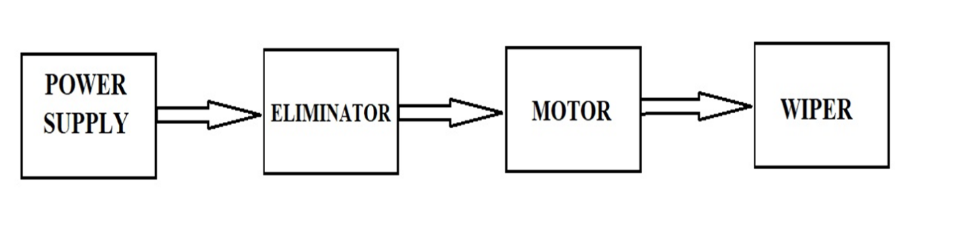

**Figure 2.2 Block diagram**

**2.3 Description of Various blocks**

When power is provided AC is converts into DC by eliminator the range of 150-300VAC of input to 24VDC as output , then the small dc electric motor rotates (back to forth). Wiper generally consist of a metal arm ,one end pivots the other end has line cotton blade attached to it .When the arms move the actual wiper blades clears the board.

**CHAPTER 3**

**HARDWARE DESCRIPTION**

**3.1 Introduction**

The principal object of the present automatic blackboard duster is to provide an attachment for writing boards in the form of a power driven erasing apparatus which can be set in operation by the throw of a switch, thus eliminating the drudgery of manually cleaning blackboards. The utility model relates to teaching aid.

**3.2 Circuit diagram**

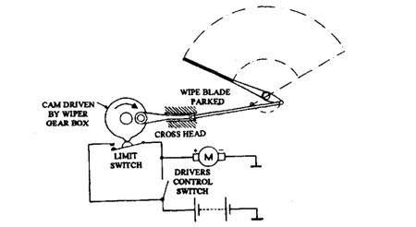

**Figure 3.2 Hardware Circuit Diagram**

**3.3 Description of components**

|  |  |  |
| --- | --- | --- |
| **S.no** | **Name of the components** | **Specification** |
| 01 | DC electric motor | 24V |
| 02 | Eliminator | 150-300VAC to 24VDC |
| 03 | Wiper arm | Length =40cm |
| 04 | Wiper blade | Length =27cm |
| 05 | Teaching board | - |

**3.3.1 DC electric motor**

Wipers are powered by a small electric motor, mounted on the under or above the board . The motor activates linkage that moves the wiper arms back and forth. The range of dc motor 24V.

**3.3.2 Eliminator**

When power is provided AC is converts into DC by eliminator the range of 150-300VAC of input to 24VDC as output , then the small dc electric motor rotates (back to forth).

**3.3.3 Wiper**

Wiper arm – this is usually made of metal. The arm transfers the movement from the wiper motor to the wiper itself. Wiper blade – it is attached with cotton to remove the dust practical in board .

**CHAPTER 4**

**RESULT AND DISCUSSION**

**4.1 Hardware Implementation**

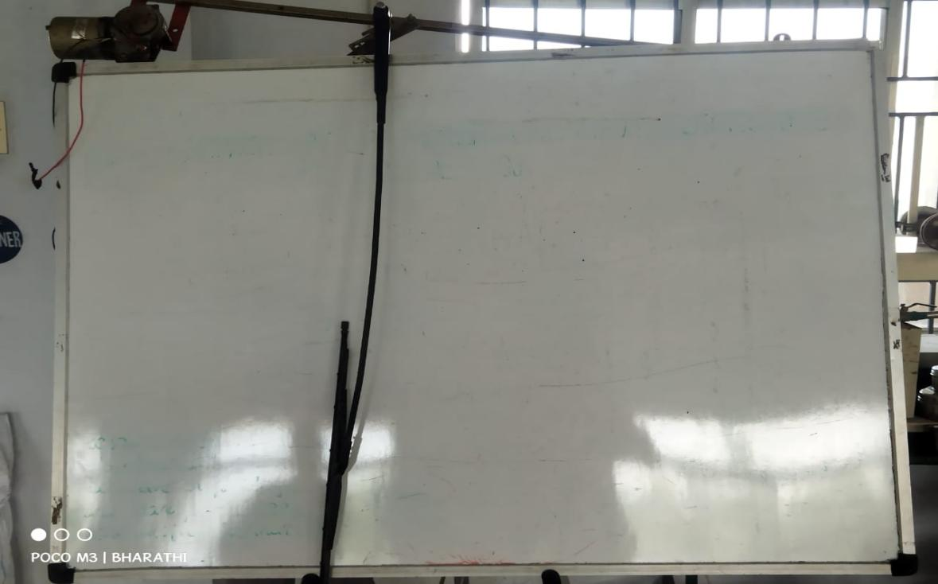

**Figure 4.1 Project Hardware**

**4.2 Working of Project model**

Board wipers are operated by an electric motor (back to forth) . The electric motor is attached to a worm gear, which transmits the necessary force to a long rod that sets the wiper arms in motion .The worm gear is able to generate the force required to move the wipers as fast as they need to move .The arms move the actual wiper blades. The blades are made of cotton cloths and must apply enough pressure to the board in order to remove the dust .The arms attach to the middle of each wiper blade, and each wiper blade has several arms that distribute the pressure onto the board evenly.

**CHAPTER 5**

**CONCLUSION AND FUTURE SCOPE**

**5.1 Conclusion**

An automatic whiteboard cleaner is a device that is generally used to clean the board automatically with the help of a mechanically driven duster. By the use of this automatic whiteboard cleaner, we can save time and energy. It is a new technology that is generally used now a day

**5.2 Applications**

It can be use for educational institute for the purpose of teaching and learning, and consume less time to clean the board. It’s rare to see Educational institutions without teaching boards, and while cleaning those boards teachers get suffered and sometimes they get affected due to dust particles. Teaching board wipers will create great impact for the teachers community for cleaning the boards.

**REFERENCES**

1)[**https://www.samarins.com/glossary/wiper-motor.html**](https://www.samarins.com/glossary/wiper-motor.html)

2)[**https://en.wikipedia.org/wiki/Windscreen_wiper**](https://en.wikipedia.org/wiki/Windscreen_wiper)

3)[**https://www.wipexchina.com/news/what-is-the-working-principle-of-the-cleaning-wiper-on-the-car.html**](https://www.wipexchina.com/news/what-is-the-working-principle-of-the-cleaning-wiper-on-the-car.html)